

International School

**Capstone Project 1**

*CMU-SE 450*

**Architecture Design**

*Version: 2.0*

*Date: 20/09/2021*

**School Connect Application**

**Submitted by:**

Nguyen Thanh Phu

Nguyen Trung Hieu

Dang Nguyen Bao Hoai

Nguyen Van Thang

**Approved by**

Nguyen Minh Nhat

**Architecture Design Review Panel Representative:**

Name Signature Date

**Capstone Project 1- Mentor:**

Name Signature Date

# Project Information

|  |  |  |  |  |
| --- | --- | --- | --- | --- |
| **Project acronym** | SConA | | | |
| **Project Title** | School Connect Application | | | |
| **Start Date** | 22-Aug-2021 | **End Date** | | 18-Dec-2021 |
| **Lead Institution** | International School, Duy Tan University | | | |
| **Project Mentor & contact details** | Name: Nguyen Minh Nhat  Email: nhatnm2010@gmail.com  Tel: +84 905 125 143 | | | |
| **Scrum Master & contact details** | Name: Nguyen Thanh Phu  Email: [thangphu104@gmai.com](mailto:thangphu104@gmai.com)  Tel: +84 772 492 301 | | | |
| **Team members** | **Name** | **Email** | **Tel** | |
| Nguyen Trung Hieu | hnguyentrung20@gmail.com | +84 975 299 149 | |
| Dang Nguyen Bao Hoai | dangbhoai@gmail.com | +84 773 305 395 | |

|  |  |  |  |
| --- | --- | --- | --- |
| **DOCUMENT INFORMATION** | | | |
| **Document Title** | Project plan | | |
| **Author(s)** | Team C1SE.44 | | |
| **Role** | C1SE.44- Architecture Design -SConA-v2.0 | | |
| **Date** | 20/09/2021 | **Filename** | C1SE.44- Architecture Design-SConAv2.0.docx- |
| **URL** | **https://github.com/PhuNguyenThang/Capstone1** | | |
| **Access** | Project and CMU Program | | |

**DOCUMENT APPROVALS**

The following signatures are required for the approval of this document.

|  |  |  |
| --- | --- | --- |
| Nguyen Minh Nhat  *Mentor* | Signature | Date |
| Nguyen Thanh Phu  *Scrum Master* | Signature | Date |
| Nguyen Trung Hieu  *Product owner* | Signature | Date |
| Dang Nguyen Bao Hoai  *Product owner* | Signature | Date |

REVISION HISTORY

|  |  |  |  |  |
| --- | --- | --- | --- | --- |
| **Version** | **Date** | **Comments** | **Author** | **Approval** |
| 1.0 | 08-Sep-2021 | Create Architecture Design Document | Nguyen Thanh Phu |  |
| 2.0 | 20-Sep-2021 | Update picture C&C, module view, allocation view | Nguyen Thanh Phu |  |

TABLE OF CONTENTS

Project Information 2

1. Introduction 5

1.1 Project overview 5

1.2 Purpose 5

2. Architecture driver 6

2.1 Business constraints 6

2.2 Technical constraints 6

2.3 Functional requirement 6

2.4 Quality attributes 6

3. Architecture overview 9

3.1 System context 9

3.2 Component and connector 10

3.3 Sequence diagram 12

3.4 Module view 16

3.5 Allocation view 17

4. ATAM 18

4.1 Present the ATAM 18

4.2 Present the business Drivers 18

4.3 Present the Architecture 18

4.4 Identify the Architecture approaches 18

4.5 Create a Quality Attribute Tree 19

4.6 Analyze the Architectural approaches 19

4.7 Brainstorm and prioritize scenarios 19

4.8 Re-analyze the architectural approaches 19

4.9 Present the results 20

5. References: 20

# Introduction

## Project overview

The School Connect Application is a miniature social network for school, this application help connect student and school in an epidemic context. Students do not need to come to school to hear announcements about upcoming events or new policies, the school can use this application for notify to students about the policies of the school. The teacher can keep contract with the students without using another app and don’t worry about personal information network social networks exposed, the student can create posts in the forum their join and see the calendar of the events that will take

With intuitive visual interface will help the teacher and student easy to use a system

This is only for student and teacher in that school, so the school can manage all account used in the system and a censor is a teacher who can manage all post and member in the forum they manage

## Purpose

This specification covers the following:

* Brief specification of the project, high-level requirement.
* Detail quality attribution.
* System context, sequence diagrams.
* Architecture presented by various view types: Component and Connect, Module view, and Allocation view.
  1. Business driver

Business Problems:

* Annoying when having to receive emails or messages in social networks to solve petty problems.
* Professors and students may not use the same communication tools so they must use many apps to can chat together.
* [During pandemic] students may not know each other, and it is difficult to work as a team.
* Messages and notifications from professors and school clubs are always missed because they do not have a separate communication channel.
* Censorship of bad conversations and comments is very difficult.
* Security: using third-party apps made information of students or teachers can be exposed.
* There are too many to post and the comment is bad to be checking.

Business Need:

* Private and security from the outside.
* Notification about events or policies for students and teachers.
* Easy students and teachers can contact together.
* No effect on personal social media accounts.
* Manager in information student and teacher
* Manager all forums in the system
* Control posting, commenting, and chat.
* Students and teachers can report comments or messages toxic.

# Architecture driver

## 2.1 Business constraints

* Sources: 3 people.
* Project was started on: 22-Aug-2021
* Project will be ended on: 18-Dec-2021
* Project will be finished in 119 days (893 hours).
* Cost: $2266.

## 2.2 Technical constraints

Technical to develop:

* Programming Language: Java, JavaScript.
* Frameworks / Libraries: Vue, Spring Boot, Bootstrap 4, Axios.
* Database Management System: MySql, FireBase.

Environment:

* Web browsers: Google Chrome, Opera.
* Operation systems: Microsoft Windows 10.

## 2.3 Functional requirement

References to Product Backlog specification of ProductBacklogV1.0.docx

## 2.4 Quality attributes

2.4.1Utility table

There are the following quality attributes that drive the design of architecture. Each quality attribute scenario is ranked with importance (I) defined by the Product Owner, and the estimated level of difficulty (D). Both values are based on a scale of High (H) - Medium (M) - Low (L).

2.4.2 Quality attributes

#### 2.4.2.1 Security

|  |  |
| --- | --- |
| Scenario: when admin, student, teacher want to use the website they need login to the system | |
| Quality Attributes | Security |
| Stimulus | Using website application |
| Source(s) of stimulus | Student or teacher, censor, admin |
| Artifacts | Information in system |
| Environment | Normal operating system |
| System response | Require user to login |
| Response measure(s) | Prevent access to the website without a login |

|  |  |
| --- | --- |
| Scenario: When an account user registers by admin, their password will be encrypted security before being saved to the database | |
| Quality Attributes | Security |
| Stimulus | Create new account |
| Source(s) of stimulus | Admin |
| Artifacts | System |
| Environment | In runtime |
| System response | Encrypt password |
| Response measure(s) | Encrypted security before being saved to the database |

#### 

|  |  |
| --- | --- |
| Scenario: Only user has role “CENSOR” can to censorship member, post or delete a post of another user in the forum | |
| Quality Attributes | Security |
| Stimulus | Censorship member, post or delete a post of another user |
| Source(s) of stimulus | Student or teacher |
| Artifacts | System |
| Environment | Normal operating system |
| System response | Do not expose those functions to the user |
| Response measure(s) | Requires users have role “CENSOR” to be able to use that function |

#### 2.4.2.2 Performance

|  |  |
| --- | --- |
| Scenario: student and teacher send a message; this message will be sent to the recipient in 10 seconds | |
| Quality Attributes | Performance |
| Stimulus | Sent message in the system |
| Source(s) of stimulus | Student or teacher, censor |
| Artifacts | System |
| Environment | Normal operating system |
| System response | The person receiving the message will receive the message |
| Response measure(s) | In 10 seconds |

|  |  |
| --- | --- |
| Scenario: student, teacher, admin create the post, the user has joined the forum have new post will receive the message in less than 15 second | |
| Quality Attributes | Performance |
| Stimulus | Create posts in the forum they join or manage |
| Source(s) of stimulus | Student or teacher, censor, admin |
| Artifacts | System |
| Environment | Normal operating system |
| System response | Another user receives notify from a new post |
| Response measure(s) | In less than 15 second |

#### 2.4.2.3 Correctness

|  |  |
| --- | --- |
| Scenario: When the student, teacher, admin operations with a tour including adding, modifying, and deleting the post, the corresponding post information will be updated correctly on the application. | |
| Quality Attributes | Correctness |
| Stimulus | Performs operations with a post |
| Source(s) of stimulus | Student, teacher, admin |
| Artifacts | Runtime |
| Environment | The System |
| System response | Change the information post |
| Response measure(s) | The corresponding tour information will be updated correctly on the application. |

#### 2.4.2.4 Modifiability

|  |  |
| --- | --- |
| Scenario: A product manager wants to develop additional features for a small social network in the next release. The system allows for expansion within 4 months of effort without affecting existing functions. | |
| Quality Attributes | Modifiability |
| Stimulus | Develop additional features for a small social network |
| Source(s) of stimulus | A product manager |
| Artifacts | The next version |
| Environment | The system |
| System response | Allows for an expansion |
| Response measure(s) | 4-person months of effort without affecting existing functions |

# Architecture overview

This section shows the diagrams which bound our target system and describe the architecture and interaction between components

## 3.1 System context

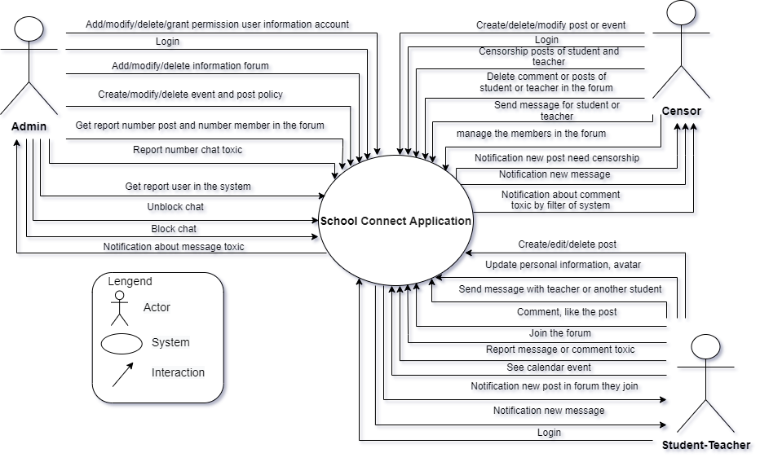

*Figure 1: System Context Overview*

* **Student-Teacher (user):**

Notification new post forum they join.

Create/edit/delete the post in the forum they join.

Login into a website.

Comment and like the post of they or another people.

Send a message to the teacher or another student in the system.

Update personal information, avatar.

See calendar event.

Join the forum.

Report message or comment toxic.

Notification new post forum they join.

Notification of new message

* **Censor:**
* Create/delete/modify the post or event
* Login into a website
* Censorship the new posts of student or teacher
* Sent message to student or teacher in the system.
* Delete comments, posts in the forum.
* Notification about comment toxic by the filter of system or teacher and student report
* Notification of the new post in the forum
* Notification of new message
* Censorship the request joins forum of the student or teacher
* Remove members from the forum
* **Admin:**
* Add/modify/delete/grant permission user information account.
* Add/modify/delete the forum.
* Get report user in the system
* Unblock chat
* Add/modify/delete event or post policy.
* Get report number chat toxic student and teacher report.
* Get report number posts and number of members in the forum.
* Login into a website.
* Block chat toxic.
* Notification about message toxic student and teacher report.

## 3.2 Component and connector

We mainly used a C&C view to argue and reason about architectural properties, quality attribute requirements, and functional requirements that the system must add here.

This view type partitions the system into components that have some runtime presence such as processes, objects, data stores, and connectors or that represent pathways of communication such as data flow and access to shared storage.

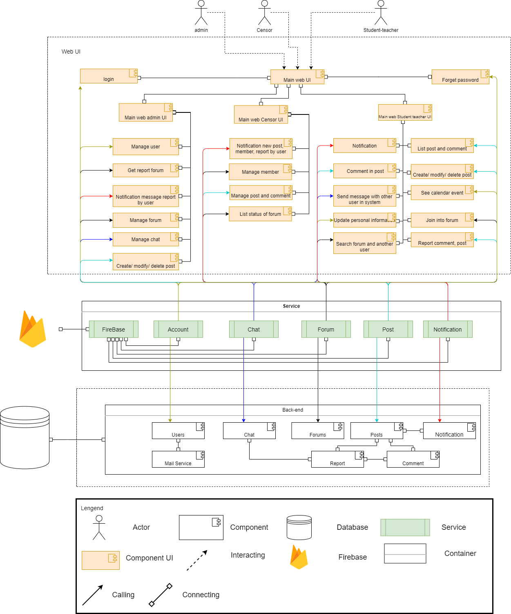

*Figure 2: C& C for SConA Website*

**Prose**

The WebUI sends and receives data from the back-end through the web service API. User operations will send requests to the server through the API, the back-end will process the data with the corresponding models and access the database to retrieve data, then respond to the information to the web client through the API to display it to the user

**Description**

|  |  |
| --- | --- |
| **Element** | **Responsibilities** |
| WebUI | WebUI is a component that manages and implements interactive functions for users that are handled on the UI. WebUI interacts directly with users, receives requests, and calls APIs from Service to handle and return results. |
| Service | Service is a component that manages and performs activities related to retrieval and storage of data such as getting the information list, user authorization. |
| Back-end | Server connect to tables in the database for transmission to the system interface |
| Account service | Service API in the backend to create, modify, delete users, and log in to the system. |
| Chat service | Service API in the backend creates room chat for the user and send chat both two users |
| Forum service | Service API in the backend create, modify, delete, forum and manage information have in a forum like a member, post, comment in the forum |
| Post service | Service API in the backend create, modify, delete, post, and user can comment in that post |
| Mail Service | Service using for send email to user |
| Notification service | Service API in the backend create notify for user can know about the new activity. |
| Firebase service | The service provides image storage solutions |
| Database | The database is a component that contains information of users, forum, post, chat… All data the system needs |

## 3.3 Sequence diagram

A sequence diagram is used to display the sequence of activities. Sequence diagrams show the workflow from a start point to the finish point detailing the many decision paths that exist in the progression of events contained in the activity

3.3.1 Login

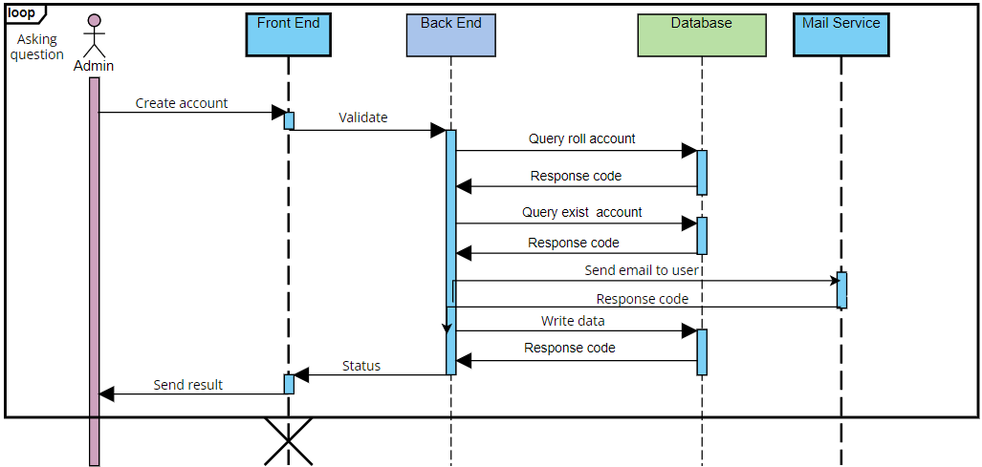

*Figure 3: Sequence diagram login*

**Description:**

To use the SConA system, users have to log in at first by using a username and password. Our system receives requests, authenticates, and returns login status.

If login successfully, one token will be created and saved in the cookie users can use all functions of the system with their permission. Otherwise, their access will be denied.

3.3.2 Create account

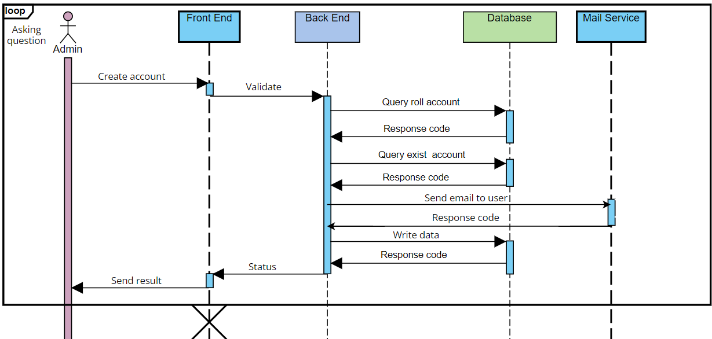

*Figure 4: Sequence diagram create account*

**Description:**

To login to the system, the user has to account created by the admin first.

Admin is allowed to create a new account, to do that admin creates a new account with code, username, email, password, full name, position, role, address, number phone, gender, date of birth. The system will check if the information is valid will save it in the database and send an email to the user

3.3.3 Create forum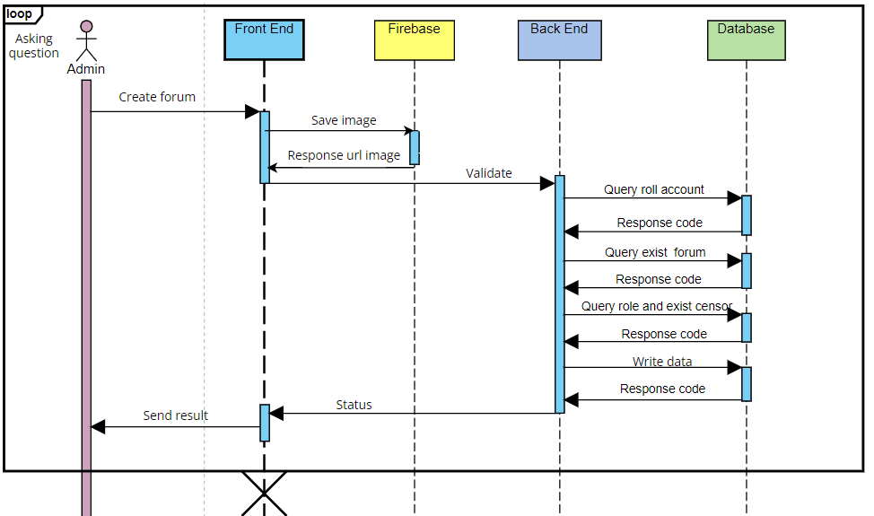

*Figure 5: Sequence diagram create a forum*

**Description:**

To join the forum, the admin needs to create the forum first.

Admin is allowed to create a new forum, to do that admin creates a new forum with name forum, select manager forum, description, and choose a cover image. The cover image will be saved in the firebase store and save URL image and information of forum was check valid in the database

3.3.4 Create post

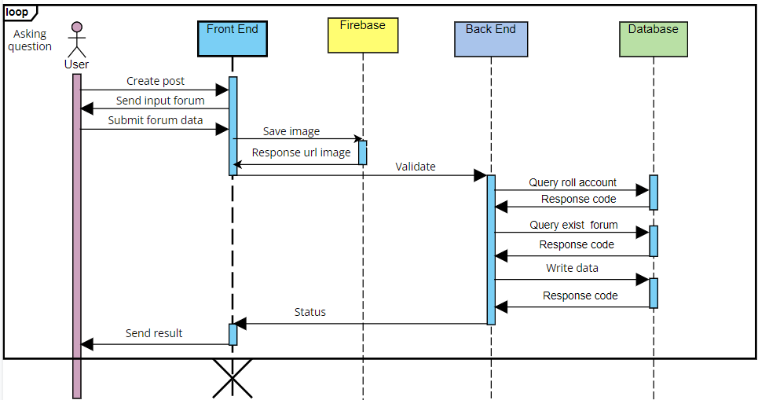

*Figure 6: Sequence diagram create a post*

**Description:**

Users are allowed to create posts in the system, to do that they have to choose that thing they will post is a normal post or event. It is a normal post user will fill in the content of the post and choose an image if have. If that is the event user needs to fill in the name of the event, the content of the event, the address of the event, date, and time of the event. If have an image so that will be saved in firebase and URL and information of post will save in the database

3.3.5 Censorship member

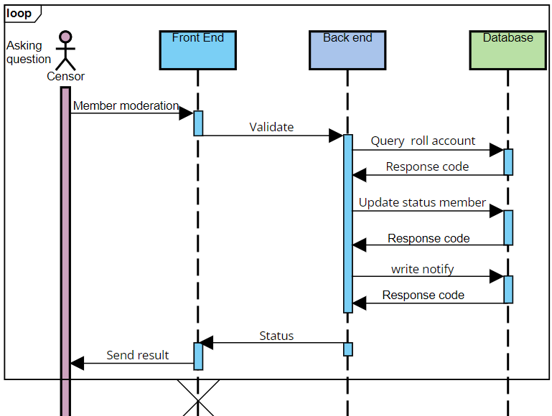

*Figure 7: Sequence diagram censorship member*

**Description:**

To student teacher can join in the forum for view create and view post in that forum, censor need censorship that member

Censors are allowed to censorship members in the system, to do that they have a login first after that they need a request list member who needs censor from the system. They can choose to allow that member to access the forum or disallow access to the forum. Our service receives requests call API to update information and save notify for a member in the database.

### 3.3.6 view post

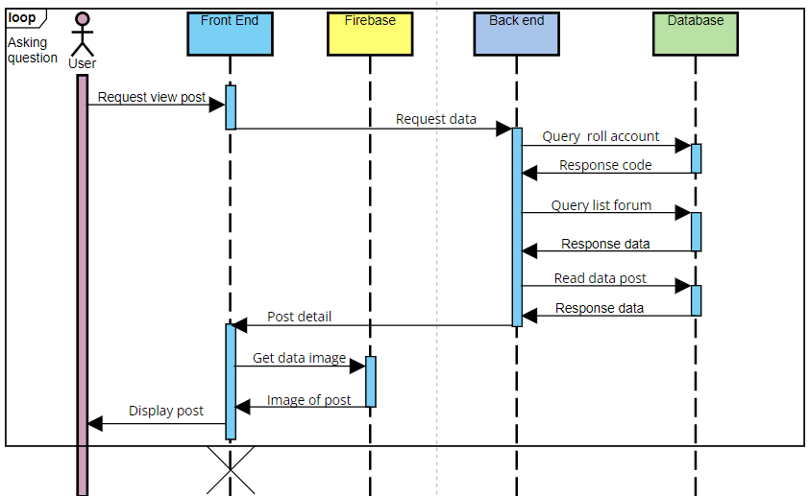

*Figure 7: Sequence diagram view post*

**Description:**

Users are allowed to view posts in the system, to do that they have to let the system know which forum they want to view post information. Our service receives requests calls API to get data and return post information, and take images from firebase if have.

3.3.7 Chat

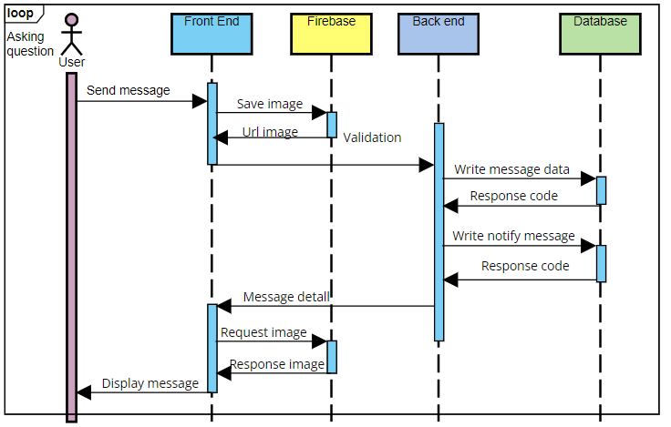

*Figure 7: Sequence diagram chat*

**Description:**

Users are allowed to interact with chat send messages to another user, input is a chat message. The application reads data if data have an image then will save in the firebase and URL and message will save in the database, Serve will send that message to user receive

## **3.4 Module view**

*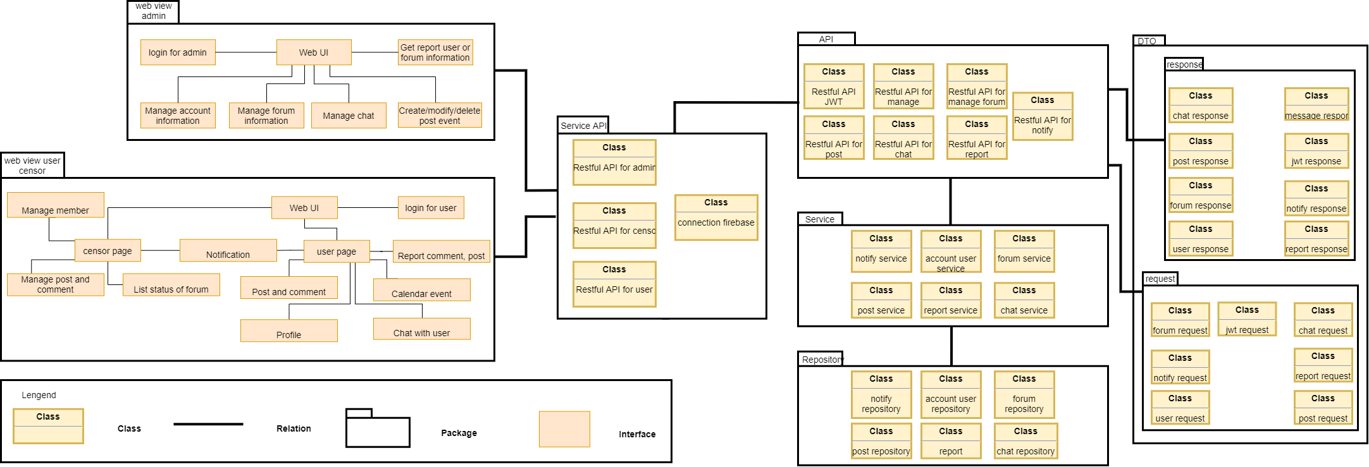Figure 8: Module view diagram*

**Prose** The system includes web view admin, web view user censor, API, service API, repository, request, response. After users interact with UI. Data will be requested to the corresponding service API, then will directed to API. Data will be requested to the controller API with data contained in the request, then will direct to service for logic handling, then will direct to the repository for reading or write data, the result will direct to controller API then save data in response. Data in response be responded to and will be displayed on UI

**Description:**

|  |  |
| --- | --- |
| **Element** | **Responsibilities** |
| API | The API package contains management and censor, student and teacher to use the functionality of the website modules for taking requests from service API and send the result to service API |
| Web view admin | The website package contains management modules for admin manage system |
| Web view user censor | The website package contains management modules for censor and teacher, a student using in the system. |
| Service API | The service package contains a class for sending a request and taking response forum API |
| Service | The service package contains a class for logic handling for the request of the user |
| Repository | The repository package contains a class for connection with the database and sends request write or read database |
| Request | The request package will contain data sent from the front end |
| Response | The response package will contain data send to the front end |

## 3.5 Allocation view

The allocation view models the run-time architecture of a system. It shows the configuration of the hardware elements when the system is deployed.

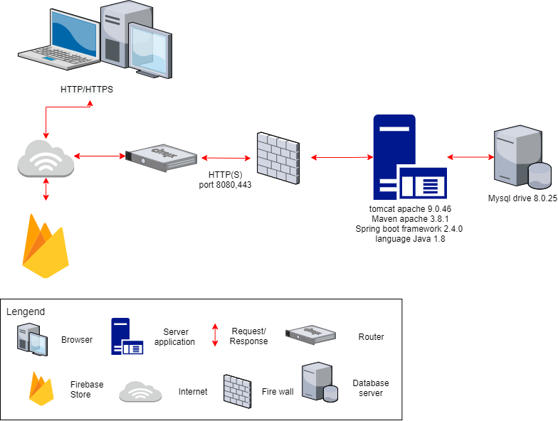

*Figure 9: Allocation view diagram*

**Prose**:

The system is deployed on a web environment (using the VUE JS framework). They interact with the server through APIs to read and write data from the MySQL database. In addition, the system interacts with the Firebase store to save the images of the system

**Description:**

|  |  |
| --- | --- |
| **Element** | **Responsibilities** |
| Laptop or PC | Device running browser and helping user to use the functions of the website. |
| Server Application | Provide an API to support the interaction between the user interface and the server. where to install and run the backend API |
| Mysql Database | The place contains all data about posts, user information, forum, ... It is organized in tabular form |
| FireBase store | The place contains all data about the image of post, avatar user, forum, ... It is organized in a tabular node |

# ATAM

## 4.1 Present the ATAM

* Overall evaluation of system architecture documents, system designs on 3 views: static view, dynamic view, and physical view based on ATAM 9 Steps method.
* Expect to achieve an accurate and objective evaluation of the architectural document. From there, the project team assesses the ability to complete the project and achieve the Architecture Drivers.

## 4.2 Present the business Drivers

* The content on the document presented the following:
  + Who are the business drivers?
  + Business problems and goals for the system are presented by the Project decision-makers.
  + System’s features.
  + System’s requirements.
  + Project constraints.
  + Project scope.

## 4.3 Present the Architecture

* Current Architecture state: The design is systematically overviewed on all 3 views: allocation view, module view, and component, and connector view.
* Expected Architecture state: The architecture is easy to understand, easy to read, full of content, clear, and responsive to the constraints and Quality Attributes of the system.
* Impact of following project constraints in the architecture:
  + Time / Deadline: Project will be finished in 119 days (893 hours).
  + Cost / Available resources: 3 people with cost $2266
  + The complexity of the problem: high
  + Quality expectations: Meet the constraints and 4 Quality Attributes described above include Security, Performance, Correctness, and Modifiability.

## 4.4 Identify the Architecture approaches

* Architecture pattern: Client-server architecture
* In the client-server architecture patterns, there are two main components: The client, which is the service requester, and the server, which is the service provider. Although both client and server may be located within the same system, they often communicate over a network on separate hardware. The client component initiates certain interactions with the server to generate the services needed. While the client components have ports that describe the needed services, the servers have ports that describe the services they provide. Both components are linked by request/reply connectors.
* The architectural blueprints are broken down into sections and interact with the services.

## 4.5 Create a Quality Attribute Tree

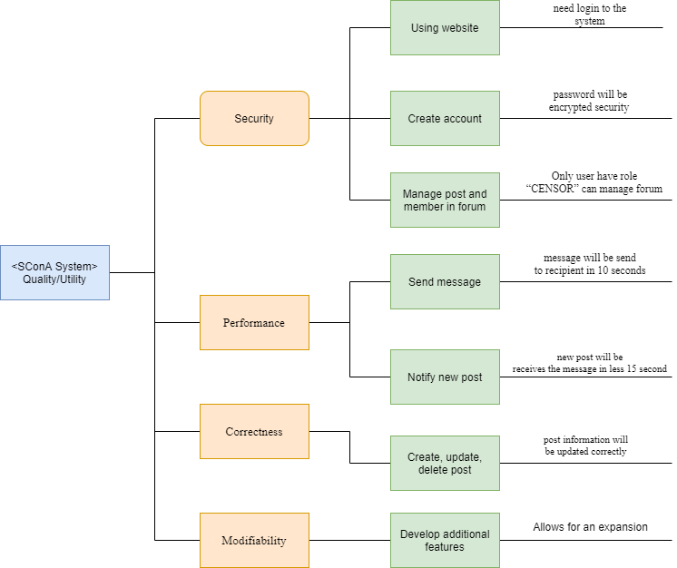

*Figure 10: Quality attribute tree*

## 4.6 Analyze the Architectural approaches

|  |  |
| --- | --- |
|  | Evaluate |
| Tradeoffs | + With client-server architecture, the performance level is enhanced and the trade-off in system security decreases  + Ease of security pays off with system performance. Meeting good performance reduces the ease of security and vice versa |
| Sensitivity points | + Depends on quite a lot on the network system and the data transmission speed of the services.  + No data backup solution yet |
| Risk and non-risk scenarios | + When security is threatened, hackers attack services, security can be affected.  + Network problem occurred.  + A service is dead. |

4.7 Brainstorm and prioritize scenarios

* Rank priority based on the constraints and attributes(descending):
  + Security
  + Performance
  + Correctness
  + Modifiability

## 4.8 Re-analyze the architectural approaches

* Validate with the system architect to discover and achieve with the system design.

## 4.9 Present the results

* Based on the above reviews:
  + The system can accommodate several Quality Attributes and constraints given.
  + However, some systemic risks will appear affecting the system and the Quality Attributes will be in the order of priority.

# References:

|  |  |  |
| --- | --- | --- |
| **No.** | **References** | **Document Information** |
| 1 | Design standards,  Document standards | https://www.softwarearchitecturebook.com/svn/main/slides/ppt/26_Standards.ppt |
| https://standards.ieee.org/standard/1471-2000.html |
| https://ieeexplore.ieee.org/document/917550 |
| 2 | Patterns | https://en.wikipedia.org/wiki/Architectural_pattern |
| 3. | Evaluation standards | https://www.iso.org/obp/ui/#iso:std:iso-iec-ieee:42030:ed-1:v1:en |
| https://gabrielfs7.github.io/software-architecture/2019/10/18/atam-analyze-evaluate-architecture/ |